**Task 1. Database Design:**

1. Create the database named "SISDB"

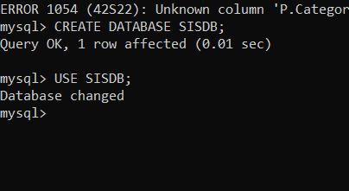

2. Define the schema for the Students, Courses, Enrollments, Teacher, and Payments tables based on the provided schema. Write SQL scripts to create the mentioned tables with appropriate data types, constraints, and relationships. a. Students b. Courses c. Enrollments d. Teacher e. Payments

1) STUDENTS

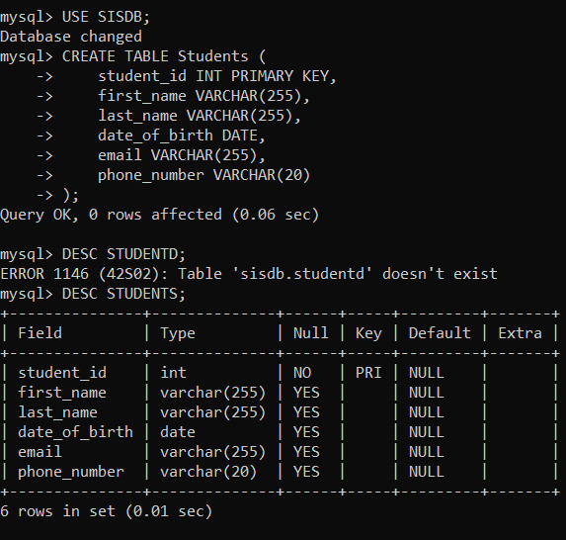

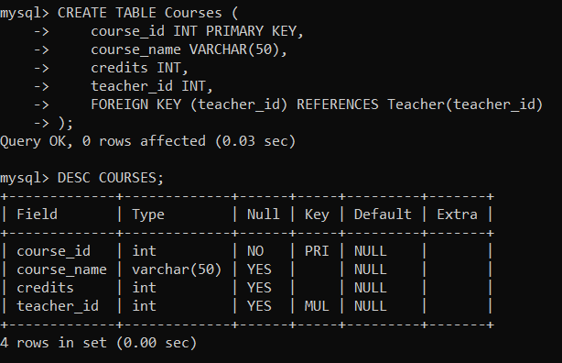

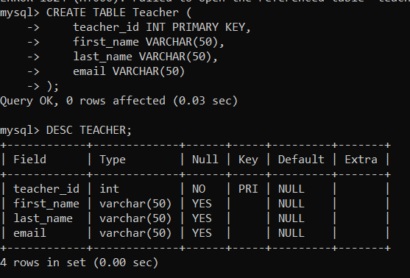

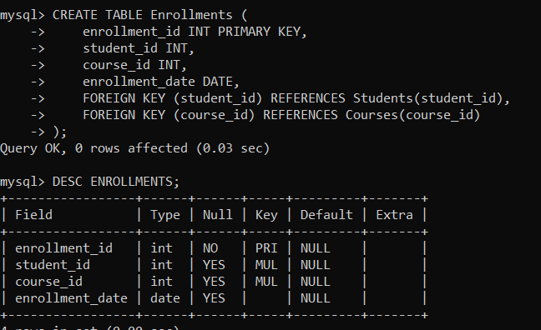

5) PAYMENTS

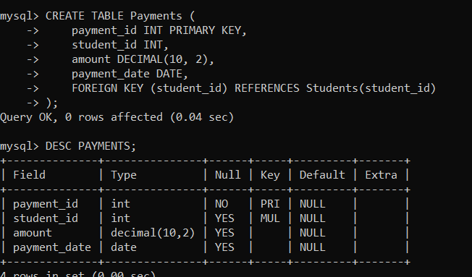

3. Create an ERD (Entity Relationship Diagram) for the database.

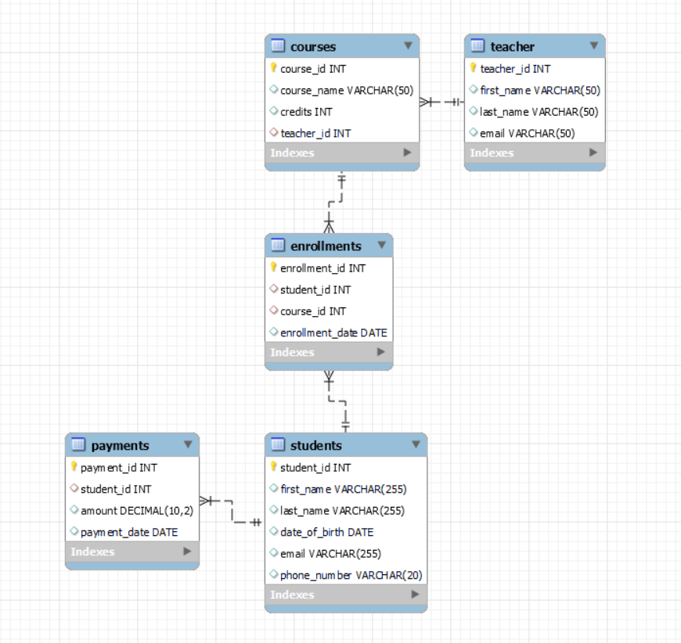

SUSHANT KUMAR SINGH

Ssushant886@gmail.com

4. Create appropriate Primary Key and Foreign Key constraints for referential integrity.

5. Insert at least 10 sample records into each of the following tables. i. Students ii. Courses iii. Enrollments iv. Teacher v. Payments

1) STUDENTS

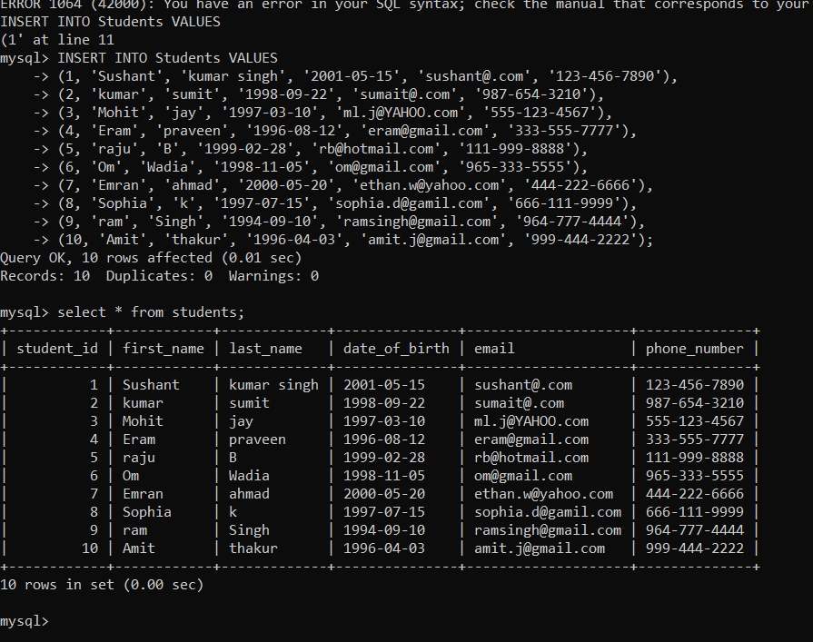

1. 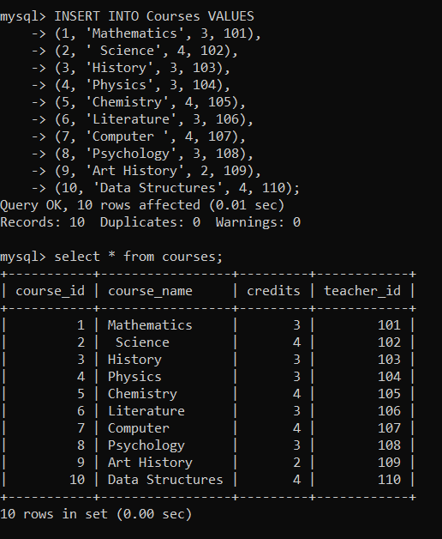COURSES
2. 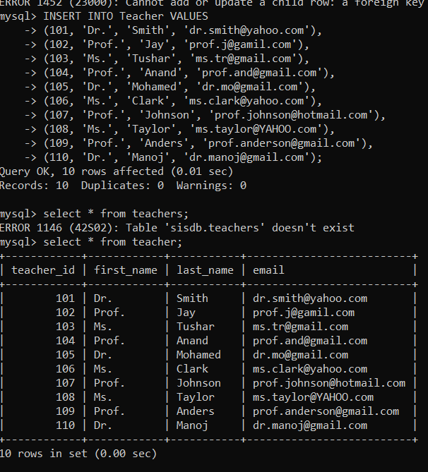TEACHER
3. ENROLLMENTS

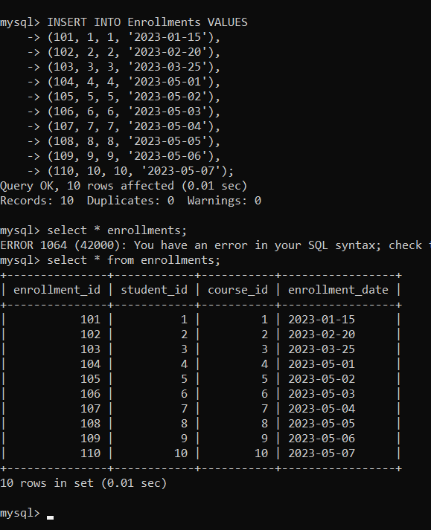

1. PAYMENTS

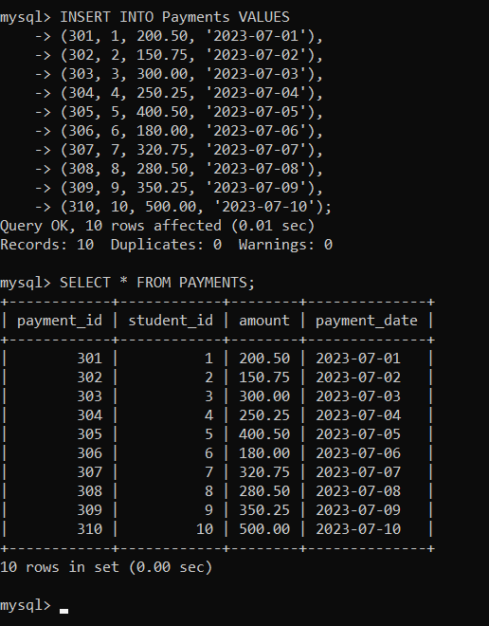

**Tasks 2: Select, Where, Between, AND, LIKE:**

1. Write an SQL query to insert a new student into the "Students" table with the following details: a. First Name: John b. Last Name: Doe c. Date of Birth: 1995-08-15 d. Email: john.doe@example.com e. Phone Number: 1234567890

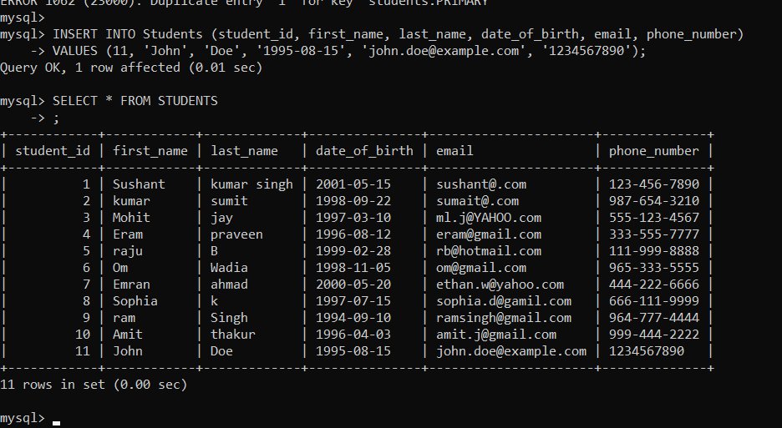

1. Write an SQL query to enroll a student in a course. Choose an existing student and course and insert a record into the "Enrollments" table with the enrollment date.

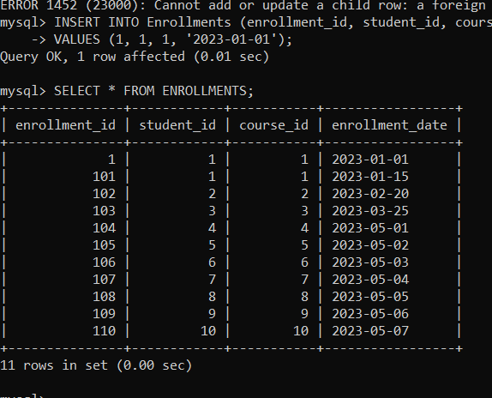

1. Update the email address of a specific teacher in the "Teacher" table. Choose any teacher and modify their email address.

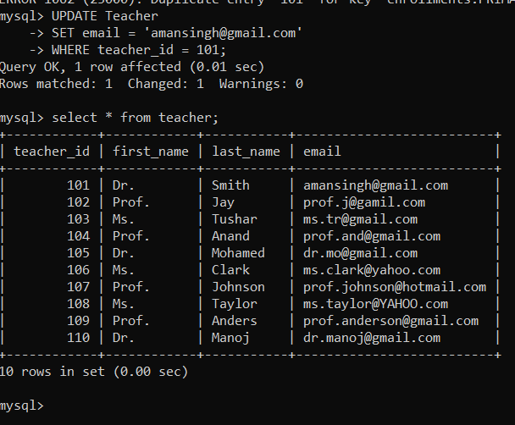

4) Write an SQL query to delete a specific enrollment record from the "Enrollments" table. Select an enrollment record based on the student and course.

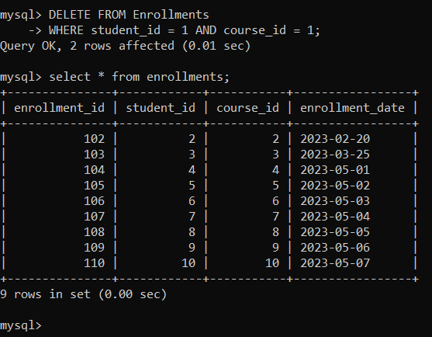

5)..Update the "Courses" table to assign a specific teacher to a course. Choose any course and teacher from the respective tables.

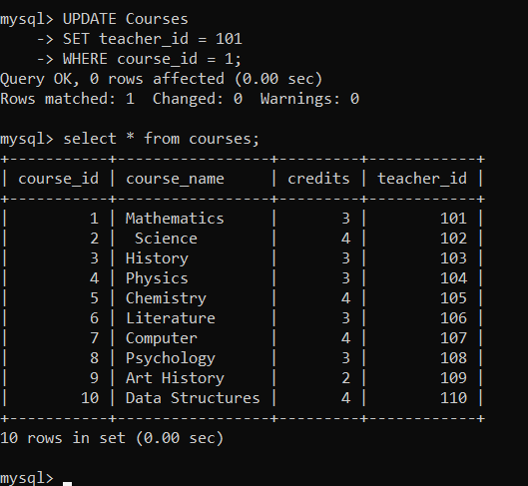

6. Delete a specific student from the "Students" table and remove all their enrollment records from the "Enrollments" table. Be sure to maintain referential integrity.

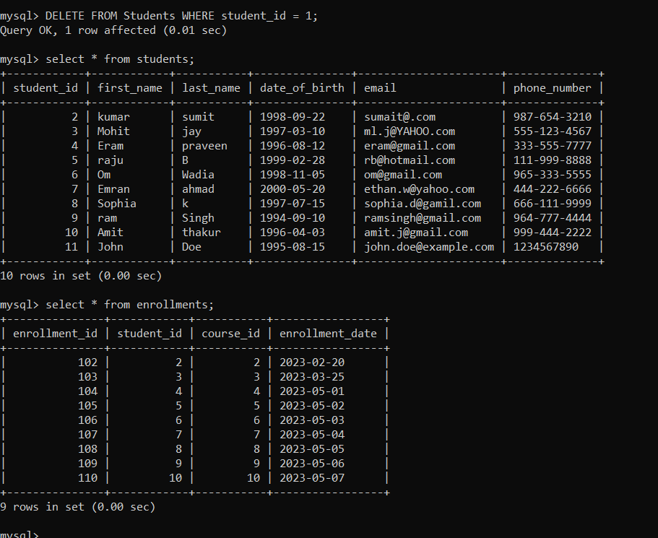

7. Update the payment amount for a specific payment record in the "Payments" table. Choose any payment record and modify the payment amount.

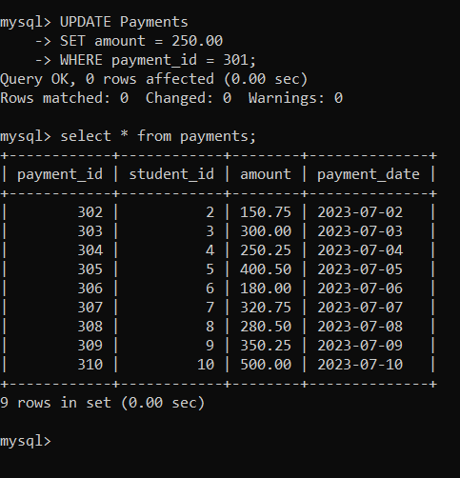

**Task 3. Aggregate functions, Having, Order By, GroupBy and Joins:**

1. Write an SQL query to calculate the total payments made by a specific student. You will need to join the "Payments" table with the "Students" table based on the student's ID.